Lab 3
Keyboard Input

Note: Create a project called Lab2 and create a new package for each exercise.

Exercise 1

Write a program to convert degrees fahrenheit to degrees celcius. The temperature should be read in from the keyboard using the in.nextDouble() method in the Scanner class. The formula to convert fahrenheit degrees to celcius is (5/9) * (fahrenheit - 32).

Sample Output
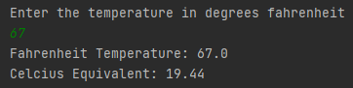

Exercise 2
Design and write a program that reads the length and width of a rectangular yard and the length and width of a rectangular house situated in the yard. These values of type double should be read in from the keyboard. Your program should compute the time required to cut the grass in the yard at the rate of 2 square meters per second.

Sample Output
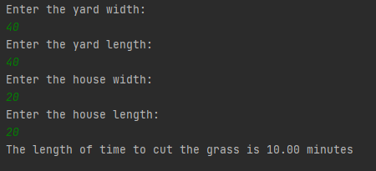

Exercise 3
Write a program that reads two floating point numbers from the keyboard using the in.nextFloat() method in the Scanner class and prints their sum, difference, and the product. Format the output to 2 decimal places.

Sample Output
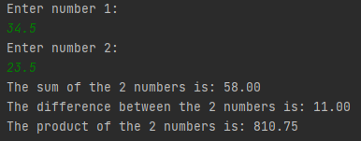

Exercise 4
Design and write a program that converts miles to kilometres. One mile equals 1.60935 kilometres. The value for miles (double) should be read from the keyboard.

Sample Output
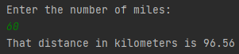

Exercise 5
Examine the following program and answer the questions that follow
// a program to print a daily schedule with the
// amount of time spent on each task.
public class Schedule
{
public static void main (String args[])
{
final int DRESS = 45;
final int EAT = 30;
final int DRIVE = 30;
final int CLASS = 60;
int totalmins = 0;
totalmins = DRESS + 3*EAT + 2*DRIVE + 4*CLASS;

System.out.println("You spend " + totalmins/60 );
System.out.println("hours and " + totalmins % 60 );
System.out.println("minutes a day on scheduled activities.");
}
}
- What is written by program Schedule (What does it do)?
- List the identifiers that are defined in program Schedule.
- Which of these identifiers are named constants?
- What is the purpose of the % in the program?

Exercise 6
Create a program to read values from the keyboard representing a time duration in hours, minutes, and seconds, then print the equivalent total number of seconds.
Sample Output
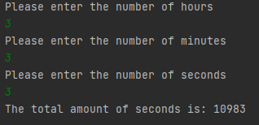
Exercise 7
Write a program that reads a value representing several seconds from the keyboard. Print the equivalent amount of time in hours, minutes, and seconds.
Sample Output
